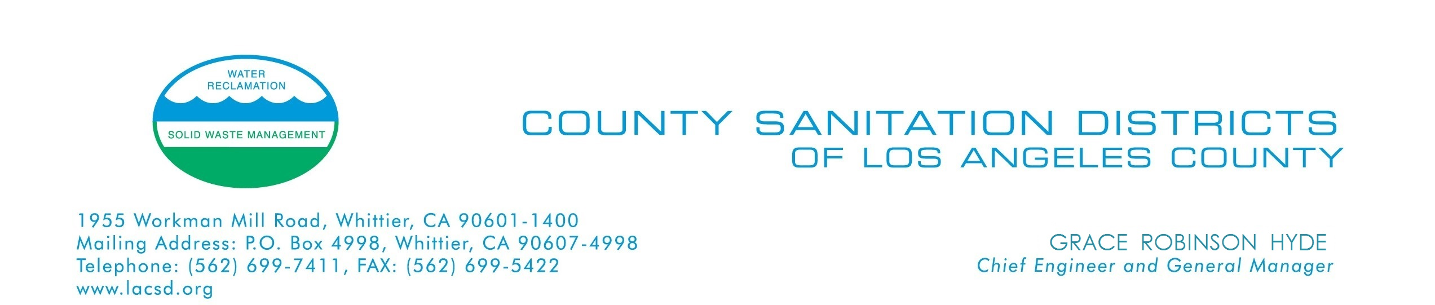
Contaminated Soil Certification Form
Instructions: Complete Sections 1 and 2 of this form. The completed form may be faxed to (562) 695-9685, Attention: Hazardous Waste Monitoring. Contact the Hazardous Waste Monitoring Staff at (562) 908-4288 ext.6005 to determine if soil sampling and laboratory testing are necessary. A completed form must be submitted and the dirt must be approved PRIOR TO ARRIVAL AT THE LANDFILL.
Section 1
Responsible Party (Person signing this certification)
Name:
Address:
Phone #: | ( ) -
Mobile #: | ( ) -

Site Source Information
Project/Site Address:
General Property Description:
Residential |  | Commercial |  |  |  | Industrial |  | Undeveloped Space |  | Native Habitat
Current and Historical Land Use/Operations:
Estimated Volume of Soil to be Excavated (yd³): |  |  |  | Cubic Yards |  |  |  |  | Estimated # of Truckloads:

Section 2
CERTIFICATION
“I certify that the CONTAMINATED DIRT I am disposing of (i) does not contain contaminated materials/substances that exceed the maximum concentration limits as defined under the provisions in the California Code of Regulations Title 22, Chapter 11, Article 3, (ii) was taken from the address and site location listed above, and (iii) that all information submitted in this Certification Form, including any attached laboratory test results, are true, representative, and correct.
Property Owner/Project Manager/Responsible Party: |  | Date:

*PRINT, SIGN AND FAX TO (562) 695-9685, ATTN: HAZARDOUS WASTE MONITORING OR E-MAIL TO LMYERS@LACSD.ORG
Section 3
OFFICE USE ONLY
WATS Transaction No.: |  |  |  |  | Authorization Expiration Date:
Dirt Accepted for:
Reuse | Disposal (circle: Lined or Unlined) |  |  |  |  | Tonnage: 1 Ton 10 Tons Tons

