LOS ANGELES COUNTY SANITATION DISTRICTS

LIQUID WASTE DISPOSAL PROGRAM

Instructions for Completing the Uniform Sewage Manifest

1. Complete the following information on the manifest:
Box for GENERATOR AND WASTE INFORMATION - to be completed by hauler or generator
Box for TRANSPORTER AND TANK INFORMATION - to be completed by hauler
Box for DISPOSAL FACILITY INFORMATION - to be completed by disposal station attendant
Box for MANIFEST RECORD - to be completed by hauler and retained for hauler record

2. Additional information for the box on GENERATOR AND WASTE INFORMATION:
For wastes picked up from generators, please provide the owner or company name, address, and phone number. For a generator that is a company, please also provide the name of the contact person. For homeowners that do not wish to disclose their phone numbers, the number of the hauler may be entered. For mixed loads, please put the information for additional generators in the space provided at the back of the manifest. For portable toilet wastes, put the hauler as the waste generator.
It is very important to properly mark down the waste type. Your waste is tested and evaluated based on the type of waste you declare on the manifest. For example, for septic tank wastes, the pH or acidity level is around the unit of 7, while for portable toilet wastes, the pH is between the units of 8 and 9. The Sanitation Districts also use other measurements like conductivity in terms of Total Dissolved Solids to evaluate a sample of your waste for conformance with the type of waste declared on the manifest. Your waste may be rejected if the waste measurement does not conform the waste type.
Wastes other than septic tank, cesspool, portable toilet wastes and trailer holding tank wastes must be written in the space provided on the manifest, e.g., sewage from lift station, pit toilet wastes, and sewage from clean-up. The Sanitation Districts accepts only human wastes at the disposal stations, and do not accept rainwater, flood water, fire-fighting water, groundwater, and other non-sewage water. The Sanitation Districts also do not accept industrial wastewater like industrial clarifier wastes, grease interceptor wastes, and car wash clarifier wastes. For questions, please email the Liquid Waste Disposal Program Coordinator liquidwaste@lacsd.org.
3. Additional information for the box on TRANSPORTER AND TANK INFORMATION:
The company number and the vehicle decal number must be completed. Both numbers can be found in the information box on the upper right-hand corner of your Permit for Wastewater Transport Truck to Discharge to the Sewerage System or from the Company Information, Vehicle and Driver Record. Ask the station attendant for assistance if you cannot locate the numbers.
(Samples of completed Manifest Forms are available on the Sanitation Districts’ Liquid Waste Disposal Website).

SANITATION DISTRICTS OF LOS ANGELES COUNTY

LIQUID WASTE DISPOSAL PROGRAM

Samples of Completed Uniform Sewage Manifests for Septic and Portable Toilet Wastes

- Septic Tank, Cesspool and Trailer Holding Tank Wastes
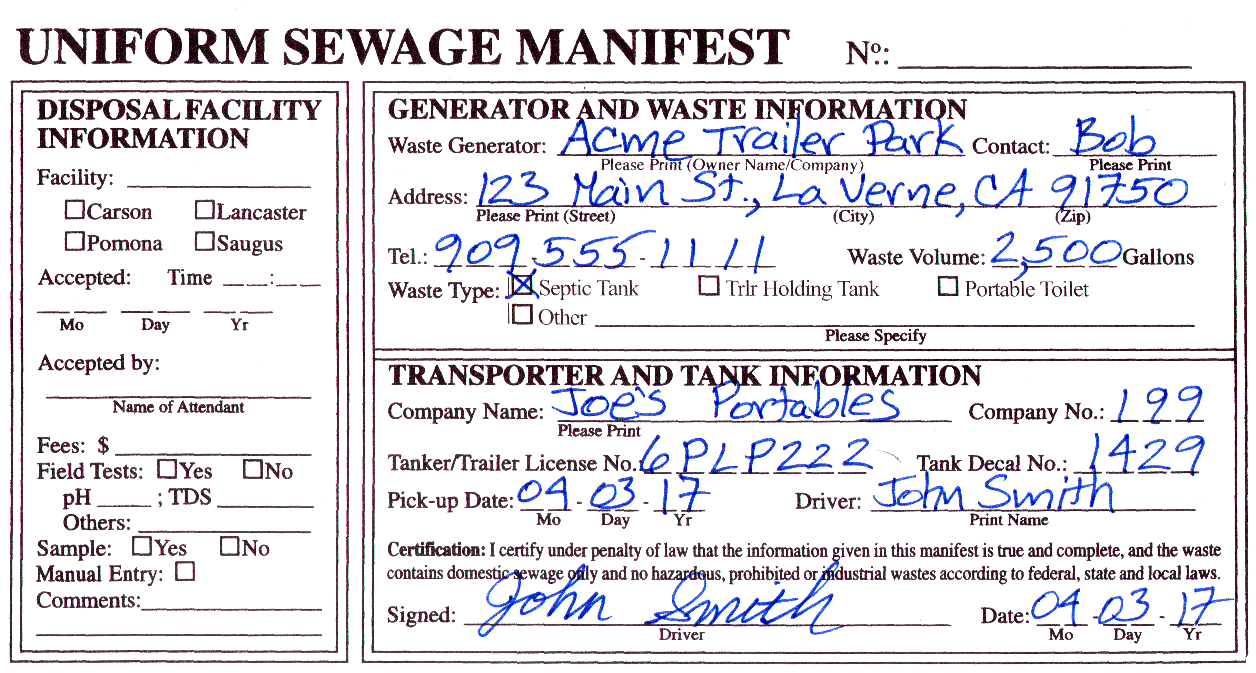

- Portable Toilet Wastes (the name of the portable toilet company can be used as the generator)
