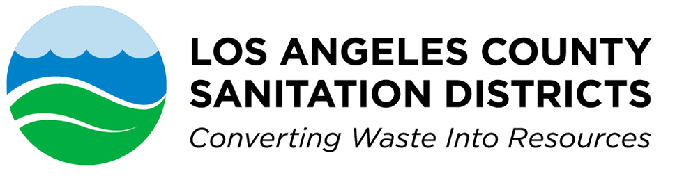

INDUSTRIAL WASTE SECTION

1955 Workman Mill Road • Whittier, CA 90601-1400

Mailing Address: P.O. Box 4998 • Whittier, CA 90607-4998

Telephone: (562) 908-4288, x2900 • FAX: (562) 908-4224
www.lacsd.org

FLOW METER CONSULTING ENGINEERS

Design ▪ Installation ▪ Maintenance ▪ Calibration ▪ Flow Measurement Systems and Devices

The following list contains the names, addresses, and telephone numbers of engineering firms, consultants and/or individuals who are currently known to be engaged in the design, installation, maintenance and/or calibration of flow measurement systems and devices. This list of engineering consultants is in no way approved or disapproved by the Sanitation Districts, but represents a partial list of those firms who have established their basic competence in the flow-monitoring field.

The Conservtech Group  Flowtrace Division  5885 Rickenbacker Rd.  City of Commerce, CA 90040  Tel: 323/867-9044  FAX: 323/867-9045  Contact: Robert MacDonald  bob@conservtechgroup.com | Douglas Environmental Group  139 E. Second St.  San Dimas, CA 91773  Tel: 909/374-0006  FAX: 801/749-3241  Contact: Douglas Iwanaga  dsmiwanaga@aol.com | Enviro-Flow Engineering Consultants  2630 Leonis Blvd.  Vernon, CA 90058  Tel: 323/589-4100  FAX: 323/589-0400  Contacts: Firas Tsipena  Firas.tsipena@enviro-flow.org | Innovative Consultants, Inc.  3740 Campus Dr., #200  Newport Beach, CA 92660  Tel: 949/756-8750  FAX: 949/261-8419  Contact: Robert Thomas  robert.t@icigroup.com

