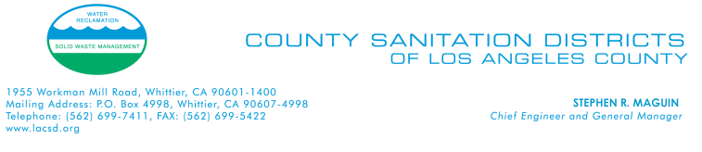

August 28, 2002

Notification of the Continued Prohibition on Brine Discharges from Self-Regenerating Water Softeners and the Imposition of New Chloride Discharge Requirements

at Santa Clarita Valley Businesses

This letter is being sent to all businesses in the Santa Clarita Valley as a reminder that it is illegal to discharge salt waste from water softening or conditioning appliances, such as self-regenerating water softeners, to the sewer. If your business has a water softener or conditioning appliance that regenerates on-site, any discharge of concentrated salt waste, also called brine, must be discontinued immediately.

As background, the Sanitation Districts of Los Angeles County (Districts) are a confederation of special districts serving the wastewater and solid waste management needs of over five million people in Los Angeles County. The Districts operate eleven wastewater treatment plants, including two water reclamation plants in the Santa Clarita Valley. The two water reclamation plants (the Saugus and Valencia Water Reclamation Plants) discharge tertiary-treated wastewater to the Santa Clara River. While the extensive treatment processes at the water reclamation plants provide a high-quality reclaimed water, they do not remove salt from wastewater. Salt passes through the plants into the river and, if present at high levels, could harm wildlife and interfere with downstream beneficial uses such as agriculture. In the Santa Clarita Valley, the component of salt that is of most concern is chloride. Chloride is best known as one of the two main parts of table and rock salt (sodium chloride).

The Los Angeles Regional Water Quality Control Board (Regional Board), a state regulatory agency, has proposed to further restrict the amount of chloride that can safely be discharged to the Santa Clara River. The Regional Board has announced that it will soon be adopting a water quality plan for the river that will result in the imposition of very stringent chloride limits on discharges from the Saugus and Valencia Water Reclamation Plants. To date the Districts are not in agreement with the Regional Board's proposed permit requirements, but have been actively participating in the process for adopting the water quality plan and providing information to the Regional Board to hopefully ensure that the final chloride limits are reasonable and based on sound science.

Because the Saugus and Valencia Water Reclamation Plants do not remove chloride, it will be necessary for all Santa Clarita-area businesses to do their part to reduce the amount of chloride entering sewers, in addition to complying with the prohibition on the discharge of brine wastes. To this end, the Districts are actively investigating potential sources of chloride discharged into the sewerage system and regulating them to the extent feasible. If source reduction is not successful, the alternative in light of the Regional Board's proposed action is to install very costly treatment processes at the Saugus and Valencia Water Reclamation Plants, which unfortunately would mean that sewer bills for Santa Clarita Valley businesses and residences would increase by four to five times over the current rate.

One significant source of chloride in sewers is self-regenerating water softeners, to which rock salt is added at the point of use on a regular basis for the purpose of resin regeneration. When water softeners regenerate, they produce a waste stream that contains significant amounts of chloride. In Santa Clarita, virtually all of the chloride that is added to a self-regenerating water softener as salt eventually ends up in the Santa Clara River. To protect the quality of the Santa Clara River, the discharge of brine to the sewer from softeners at businesses has been prohibited in Santa Clarita since 1961. Through on-site inspections, the Districts have found that self-regenerating water softeners have been illegally installed at several commercial businesses in the Santa Clarita Valley, and, due to the impending regulations of chloride discharges, we are taking actions to ensure that the prohibition is being strictly observed by all businesses.

If your business is currently operating a self-regenerating water softener or other water conditioning system that generates a brine waste, you must immediately stop discharging brines from the unit and adopt an alternative brine disposal method. This prohibition applies regardless of whether you add the salt to a water-softening unit yourself or if you employ water conditioning service provider to add salt to a softener. The prohibition also applies to any business that uses a point-of-use treatment system, such as a reverse osmosis system, that generates a brine waste. Note that it is also illegal to discharge brines into gutters or storm drains, as these structures flow directly to the Santa Clara River without treatment. If soft water is necessary for your business, you may use water softening exchange tanks that are regenerated off-site at a facility that is permitted to accept salt discharges. There are local businesses that offer exchange tank services. Another option is to collect the brine waste and arrange for a service to properly dispose of it. Please be advised that representatives of the Districts’ Industrial Waste Section are visiting businesses in the Santa Clarita Valley to make sure the prohibition on the discharge of brine wastes is being followed.

In addition to water softener brines, your business may generate other types of chloride waste that is sewered. The Districts are currently conducting a study to identify practices that can reduce sources of chloride-containing wastewater at commercial businesses in Santa Clarita to the extent that is economically and technically feasible. The Districts, along with their representatives, will be performing inspections of local businesses over the next several months as part of this study. Based on the study results, the Districts will be developing a set of available best management practices and requiring Santa Clarita-area businesses to adopt those that are economically and technologically feasible to reduce the discharge of chlorides. You will be notified by mail of any new requirements imposed on your business.

The Districts are firmly committed to continuing to provide an environmentally sound and low cost sewerage service to the residents and businesses in the Santa Clarita Valley. However, as set forth above, this goal is threatened by the action proposed by the Regional Board to unreasonably limit the discharge of chloride to the Santa Clara River. The Districts believe that the environmental integrity of the river and its beneficial uses can be protected without resorting to the extremely restrictive discharge limitations being proposed by the Regional Board.

The Districts appreciate your cooperation in minimizing your company's chloride discharges to the sewer and thus helping to significantly reduce chloride discharges to the Santa Clara River without the addition of extraordinarily expensive treatment processes at the Districts' facilities. For more information on chloride and water quality, please visit the following web-site: www.santa-clarita.com/cityhall/pbs/environment/chlorides.htm. If you have any questions about the requirements outlined in this letter, contact Preeti Ghuman of the Districts’ Industrial Waste Section at 562/699-7411, extension 2904.

Very truly yours,

Stephen R. Maguin
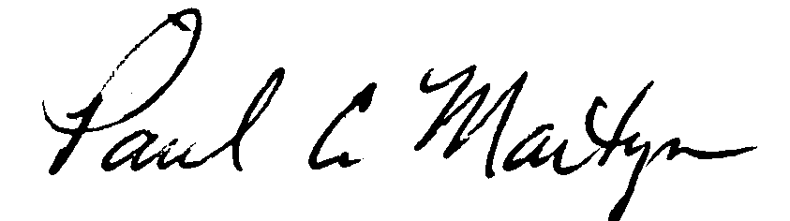
Paul C. Martyn
Head, Industrial Waste Section
PCM:dfd
PC Docs: 147048

